Contents
Important Note Regarding Users 2
Log In 2
In Cayuse IRB 2
Top Banner 2
Top Bar of Dashboard 2
My Role 2
Dashboard 2
Entering a New Study 4
Submission Details Screen 5
Enter Data 6
Research Personnel 6
Save 8
Submission Information 9
Submission Information Menu 9
Study Returned to Researcher 11
Log Out 12
Routing Workflows 13
In-Draft Workflow 13
Awaiting Authorization Workflow 13
Pre-Review Workflow 13
Under Review Workflow 13
Post-Review Workflow 13
Submission Details 13

Important Note Regarding Users
Important Note: If the person is not in the system and/or from another institution, send the person’s name, username, email address, phone number, and GSU department (if applicable) to IRB@govst.edu with a subject of “Request to add individuals to Cayuse IRB.”
Most students are not in the system.

Log In
Use your GSU username and password to log into the GSU Ethos Sign-on page. The Evisions Research Suite page opens.

In Cayuse IRB
Go to Cayuse IRB at govst.cayuse424.com. Once logged in, choose the Cayuse IRB site link.

Top Banner
The top banner contains current announcements from IRB. After reviewing the announcement, click close to dismiss the banner.

Top Bar of Dashboard
The top bar contains Menu (hamburger icon), <Name of Current Menu Item>, Notifications Bell, and User Name with Actions. Notifications are email notifications of studies in progress. Notifications can be deleted.

My Role
If you have more than one role in Cayuse IRB, choose your role from the dropdown menu.
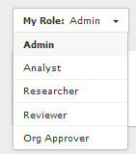

Dashboard
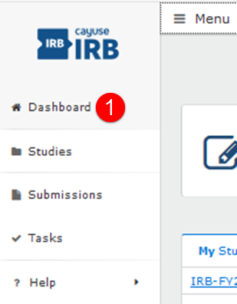

- Click on Menu and go to Dashboard. Dashboard is your home base.
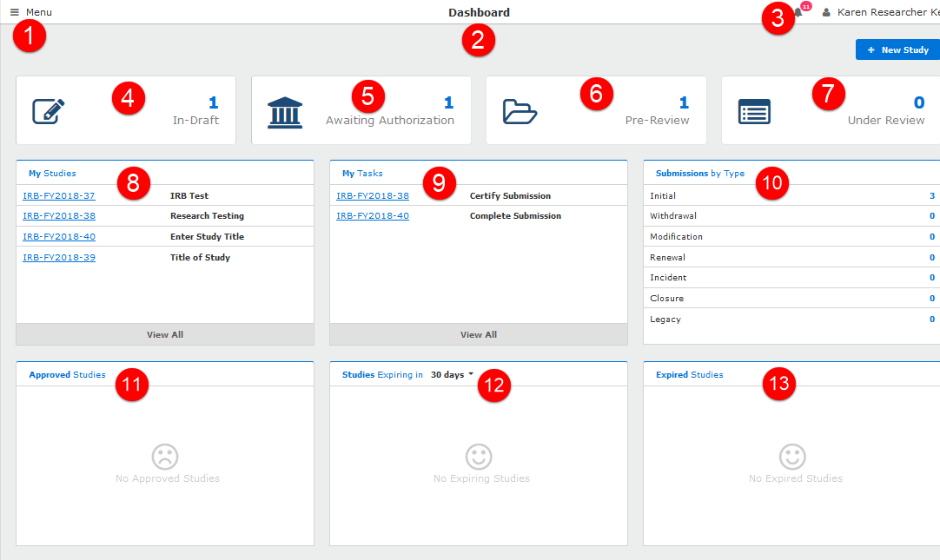

- Menu: Contains links to your Dashboard, your studies, and Help Guides.
- Dashboard: All studies in progress.
- Notifications: All of your email notifications of studies in progress.
- In-Draft: Submissions in draft mode.
- Awaiting Authorization: Submissions that are waiting for authorization/certification.
- Pre-Review: Studies that are under review by an IRB analyst.
- Under Review: Studies that have been assigned to an analyst.
- My Studies: List of all your studies.
- My Tasks: Items in a workflow that need your attention.
- Submissions by Type: Submissions categorized by type of submission.
- Approved Studies: Studies that have been approved.
- Studies Expiring in days: Choose the dropdown number of days to view studies that are expiring.
- Expired Studies: Studies that have expired.

Entering a New Study
- Choose NEW STUDY button on the top right. Add image.
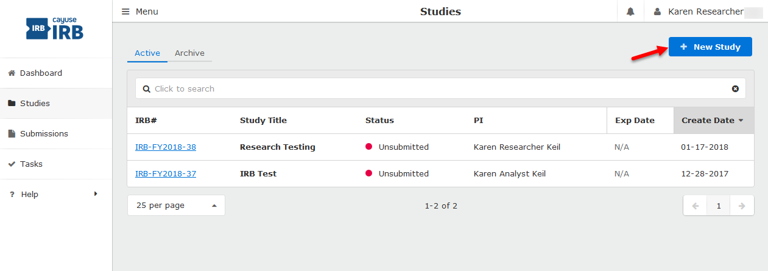
- Study Details: Enter Study Title and click the blue check mark.

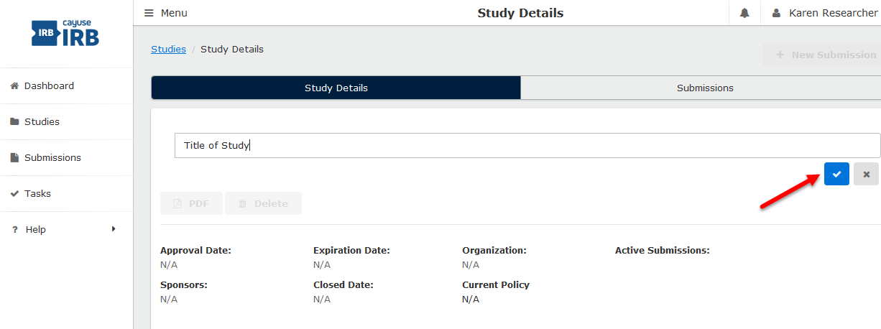
The system automatically assigns an IRB project number.
Project numbers are formatted by IRB-FY2018-###.
- Choose NEW SUBMISSION button at the top right of the screen to complete a new study (protocol).
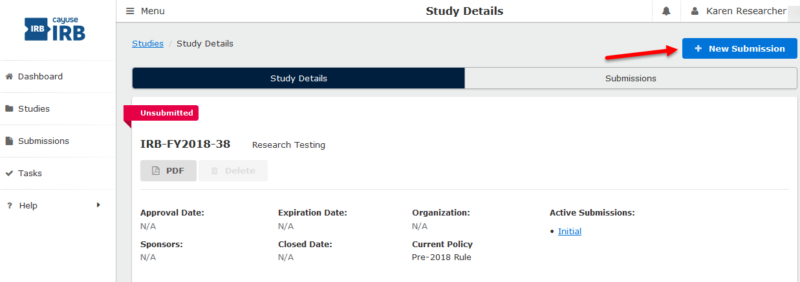
- Choose the type of submission from the dropdown menu.
- INITIAL for new study
- Project Renewal/Annual Review
- Modification
- Incident
- Withdrawal
- Closure

Submission Details Screen

The Submission Details screen automatically opens.
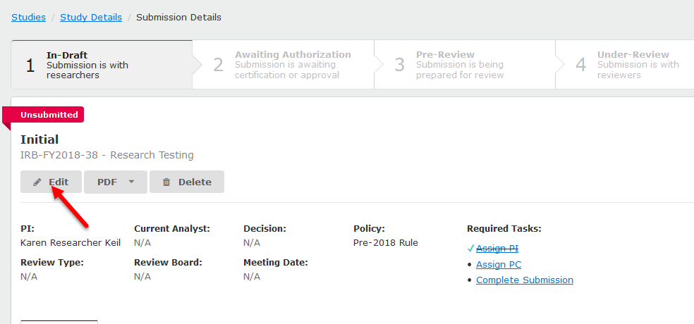
Each study can have one or more submissions associated with it.
When you first create a study, you must begin by creating an Initial submission (or a Legacy submission if the study was imported from a previous system). The Submissions screen lists all of the submissions relating to the studies that you have access to.
Note: Some of the submissions are different types of submissions for the same study. For instance, an initial submission that was later followed up by a modification submission for that study.

Enter Data

As you work through completing items in the study, you can save each item as you move through the questions.
Note: As you work through submitting a study, please note that you will see question marks to the right of questions throughout. If you click on a question mark, you will see information that will assist you for that particular question.

Research Personnel

Important Note: If the person is not in the system and/or from another institution, send the person’s name, username, email address, phone number, and GSU department (if applicable) to IRB@govst.edu with a subject of “Request to add individuals to Cayuse IRB.” Most students are not in the system.
- Primary Contact
Your name automatically populates. If you need to change the primary contact, use the FIND PEOPLE button and choose only one person. Can be a student, but do not add your department chair unless they are involved in the project.
- Principal Investigator/Project Director (PI/PD)
Use the FIND PEOPLE button and choose one person who is eligible to be PI/PD at GSU. If you are a student, insert the faculty member’s name as PI.
PI/PD cannot be a student.
For students, research advisor is the PI. Use the FIND PEOPLE button and choose only one person. Cannot be a student.
Use the ATTACH* button to attach a file with a descriptive, identifying name to the certificate of training from CITI. Be sure the certificate specifies scores.
- Co-Principal Investigator
Co-PI cannot be a student.
If there is no Co-PI, go to Question 4.
If yes, choose the person(s).
Use the ATTACH* button to attach a file with a descriptive, identifying name to the certificate of training from CITI. Be sure the certificate specifies scores.

- Student Driven
Not for student groups.
If not student driven, go to Question 5. If yes, use the FIND PEOPLE button and choose only one Student Investigator.
Enter the student’s academic program and degree sought.
Use the ATTACH* button to attach a file with a descriptive, identifying name to the certificate of training from CITI. Be sure the certificate specifies scores.

Important Note: If the person is not in the system and/or from another institution, send the person’s name, username, email address, phone number, and GSU department (if applicable) to IRB@govst.edu with a subject of “Request to add individuals to Cayuse IRB.” Most students are not in the system.

- Additional Research Personnel
Add anyone involved in the research. Involved defined: Anyone that you want to have access to the study. While not recommended, you can add Research Personnel later as a modification to the study.
If no additional research personnel, go to Question 6.
Use the ATTACH* button to attach a file with a descriptive, identifying name to the certificate of training from CITI. Be sure the certificate specifies scores.
- Study Personnel Qualifications and Expertise
Enter the qualifications and/or expertise for each named research personnel in your study.
Enter qualifications that are relevant to the study.
ATTACH instructions are on the next page.
*How to ATTACH a File
- Click the ATTACH button, then click the + (plus) sign Add File.
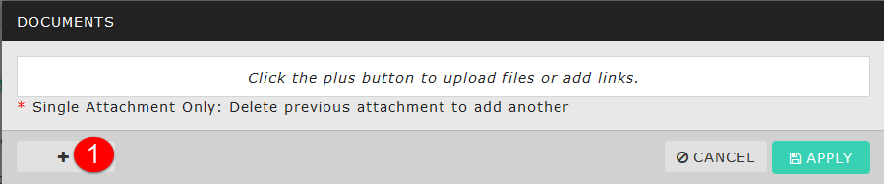
- Click ADD FILE.
A FILE UPLOAD window automatically appears. Choose the file to attach.
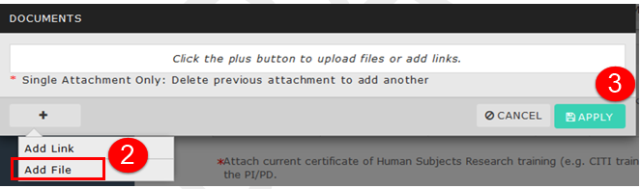

- Click APPLY.

Save
Save your entries by clicking the SAVE button at the top right of the page.

When you have completed all information needed for each section, you will see a green check mark next to the completed section in the section menu.
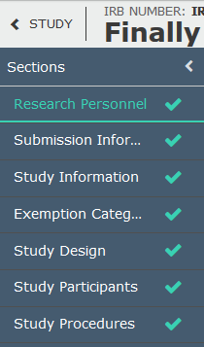

Submission Information
Click on Submission Information in the left navigation menu.
- Type of Activity
Choose the type of activity.
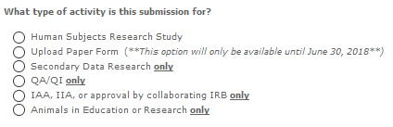
Note: As you choose the activity type, the submissions information menu changes. Hence, each activity type requires unique Submission Information.
- Materials in any language other than English
If all materials are in English, choose No, and go to question 3.
If yes, follow the instructions that appear.

- Funding agency or research sponsor
If no funding agency, choose No, and go to question 4.
If yes, a FUNDING section will appear in the Submissions Information menu.
- Multi-institution research
If no other institutions are involved, click SAVE at the top right of the screen.
If yes, other institutions are involved, go to question 5.
- IRB of Record
Complete the set of questions. Then, click SAVE at the top right of the screen.

Submission Information Menu

Depending on the type of activity for the research project, your Submission Information may contain some or all of the items below.
Continue and complete each section. Required fields are marked with a red asterisk. While you can save at any time, you complete a section without all required fields are answered.
When a section is complete, you will see a green checkmark to the right of the menu item.
Possible Submission Information required:
Study Information
Study Design
Study Participants
Study Procedures
Benefits and Risks
Confidentiality of Data
Funding
Existing Data Research
IACUC Protocol Submission
IRB Paper Submission
Conflict of Interest
Attachments

Work your way through the information required.
When all items are complete, click the SAVE button at the top right of the page.
On the left task menu, click on Ready to Submit or Complete Submission.
Click Yes to confirm submission.
Scroll to the bottom of the page, and click on Certify. If you are brought to the Submission Details screen, click the Certify button.
Then Confirm your certification.
The study status updates to Waiting Org Approval.
Be sure to log out of the system!

Study Returned to Researcher
If your study has been returned to you, you must return to your study, read the comments, and complete the actions required.
- Go to My Dashboard > My Tasks
- Click on the IRB number that has been returned to you. The status is Complete Submission.
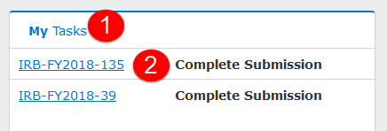
- When the study opens, the status will be Reopened. Click on EDIT.
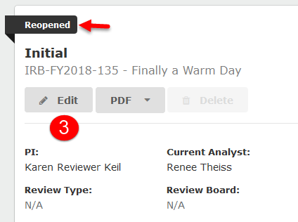
- Look in the Sections Menu for Comments. Comments are identified as a green callout with the number of comments in the section.
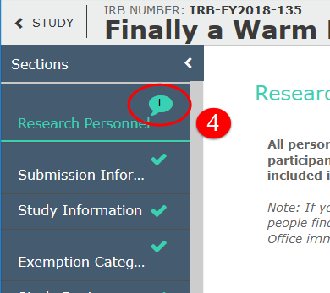
- Click on Expand Comments.
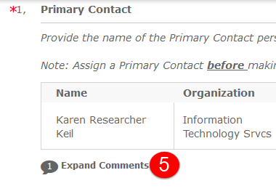
- Read the comments and take action.
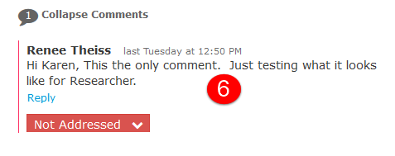
- After you have completed the action, choose Addressed from the dropdown menu.
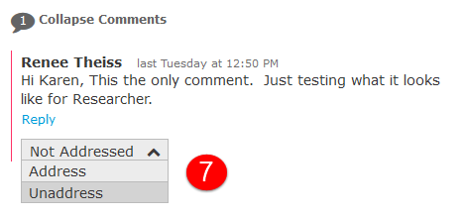
- When complete, the Addressed dropdown will be green.
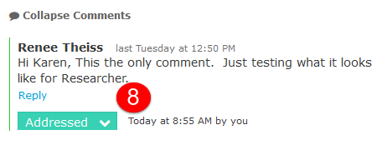
Repeat for all comments in each section.
- When finished, click on Complete Submission.
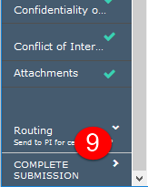
Click Yes to confirm submission.
Then click on Certify.
Then Confirm your certification.

Log Out
To log out of the system, click on your name in right top corner. Choose Log Out.
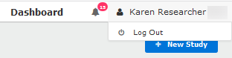

Routing Workflows

In-Draft Workflow:
- Complete required task lists
- Complete required sections
- Routing: Send to PI for certification. Then, choose COMPLETE SUBMISSION.
Awaiting Authorization Workflow:
- PI and Co-PIs CERTIFY the submission. Note: PI or co-PI can return the study to the author(s) for further editing.
- Org Approvers CERTIFY the study (2-levels, with organization hierarchy).
  - Chair/Program Director/Immediate Supervisor
  - Dean/Designee/Immediate Supervisor of Person in a).

Pre-Review Workflow
- Assigned to Analyst
- Pre-reviewed by Analyst.
- Analyst assigns Reviewer.

Under Review Workflow
Reviewer is reviewing.

Post-Review Workflow
- Analyst checks Reviewers comments and decisions.
- Analyst prepares and sends letters or notifications.

Submission Details
You may then view your submission and/or create a PDF of your submission.

