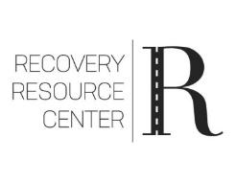
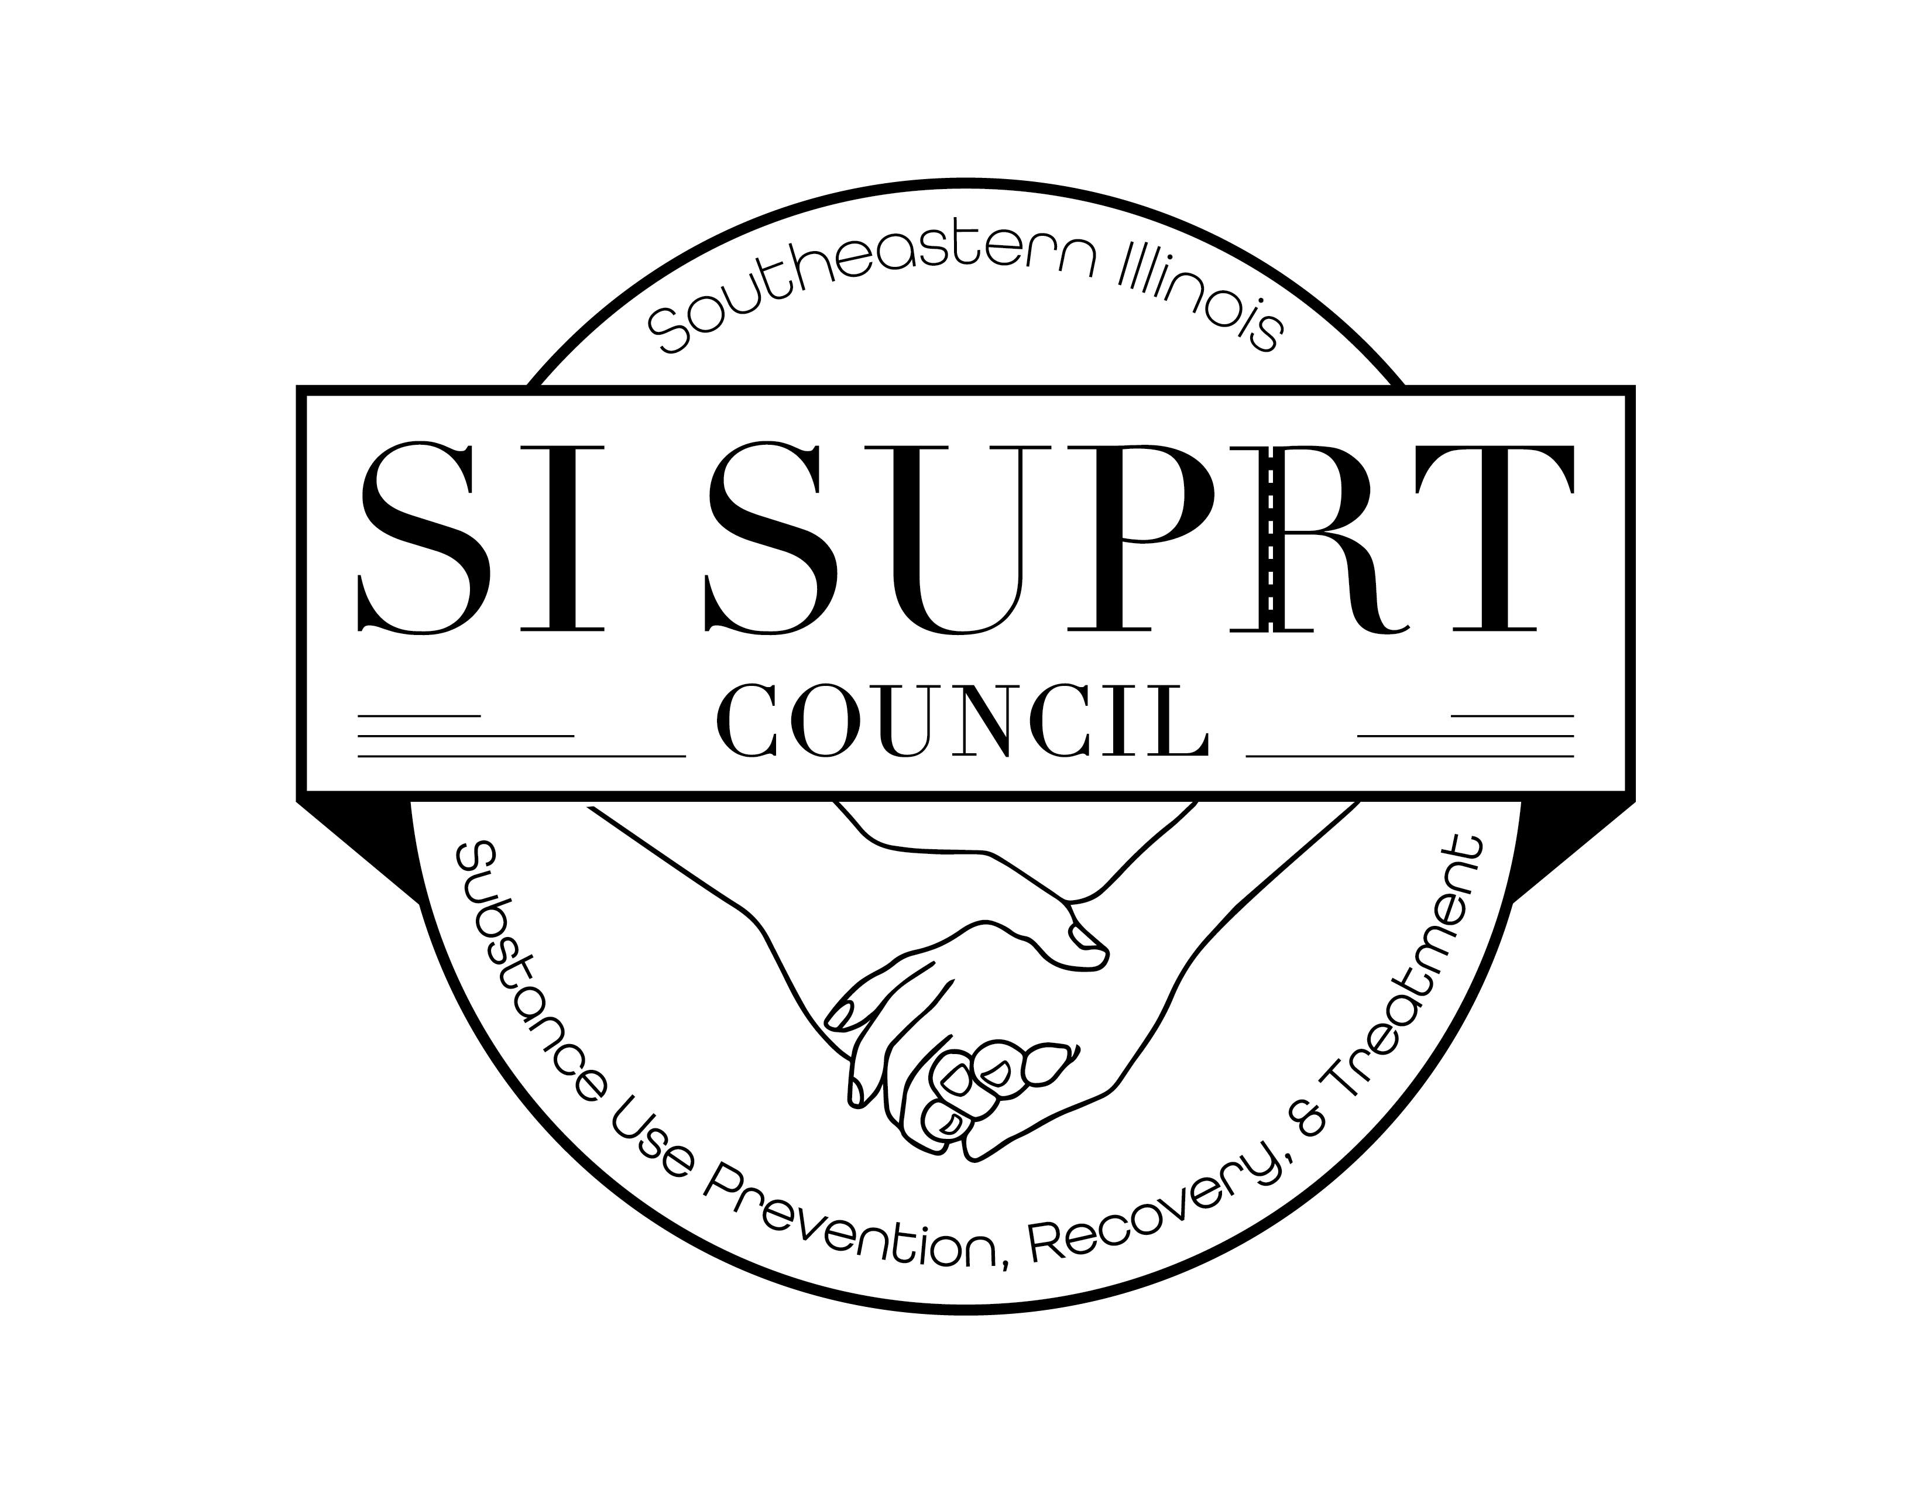
SI SUPRT Meeting Minutes
May 3, 2023, 12:00-1:00 ZOOM and In-Person

Introductions and Welcome:

In-Person attendance:

Chris Dennis, EHD
Katie Unthank, EHD
Danielle Camp, EHD
Drew Donelson, EHD
Danielle Bradley, EHD
Amy Oxford, Senator Fowlers Office
Misty Smith, EHD
Holly Kotner, EHD
Matthew Shaffer, EHD
Kat Houghton, EHD
Natalie Marvel, EHD
Hailey Parker, EHD
Stacey Miller, EHD

Virtual attendance:

Bradley Bullock, TASC
Garrett Rowden, CAP
Kelli Corner, SIH/SIU
Dr. Michael Blain, HMC
Brittany Bulfer, EHD
Bev Holland, Region 5
Jesse Nelson, PLE
Julie Pohlman, ROSC
Katt Holiday, Arrowleaf
Kindra York, EHD
Selwa Yatim-Barda, Tactical Recovery
Justin Day, EHD
Craig Loddeke, PAL
Johanna Gonzalez, ROSC
Misty Eftin, EHD
Brittany Davis, EHD
Marissa Odum, TAT
Tricia Harrison, EHD
Andy Greer, Gateway
Victoria Atchison

Standing Coalition Business:
- Minutes from the April meeting were approved unanimously with a motion made by Danielle Bradley. Matt Shaffer seconded the motion.

New and Standing Coalition Reports:
- Craig Loddeke (Parents of Addicted Loved Ones) presented on their program and the services they provided.
- Kelli Corner (SIH/SIU) shared slides showing statistics on addiction, including opioids, marijuana, alcohol, and nicotine. Also spoke on the QUIT LINE, reminding us of the assistance that is available.
- Chris Dennis reported on the laundry event held in White County. It was well attended with 130 loads of laundry being done and 55+ attendees, and 26 NARCAN kits distributed. He also announced an additional laundry event will take place in June in Saline County in partnership with First Presbyterian Church.
- A Recovery Walk is scheduled for Sept.21st. This will be held in Saline County. A fee of $20.00 is due for the shelter to be used for the event. Misty Smith made the motion to approve this expense and Kindra York seconded it. Ordering T-shirts was also agreed upon. Danielle Camp made the motion with Danielle Bradley seconding it.
- Andy Greer (Gateway) spoke on “Her Story,” a new support group for women coping with exceptional trauma, and those battling addiction.
- NARCAN reports show that 300 individuals were trained on the use of NARCAN and 700 kits were distributed.
- Katie Unthank lead the discussion surrounding the NARCAN dispensing machines and the placements of those.

Meeting was adjourned.

Next Meeting: June 7, 2023

