Take Action Coalition of Clinton County -- In The News -- July 2023

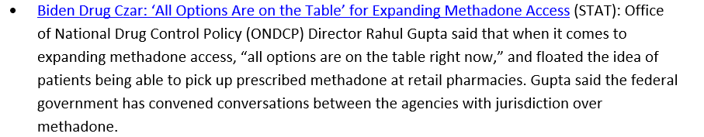
https://www.statnews.com/2023/05/18/opioid-addiction-methadone-access-drug-czar/?mkt_tok=NzczLU1KRi0zNzkAAAGMY3xkO_ZIyX52BBjwSYZdCynkK2e6YkSTzVpybDsadxY7vEFErdcN6rtMUngdzjYD3KdzijURPEH3ORCO1mrL0ulU_AV0LdzE43imF3OY7Tg

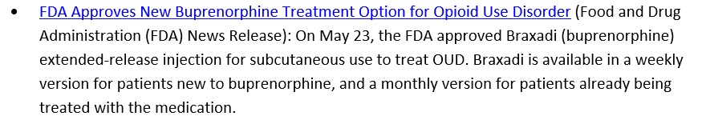
https://www.fda.gov/news-events/press-announcements/fda-approves-new-buprenorphine-treatment-option-opioid-use-disorder?mkt_tok=NzczLU1KRi0zNzkAAAGMY3xkOzcIjrWZt6gNh3ZE9f17WJisdfhuM26Uqj_tq4wXzLkFGrOqBU3J5ilE5dnoxUAxS0W87qOK23_h3_6G-nctZ-YT66bAm0MTG2PnAqU
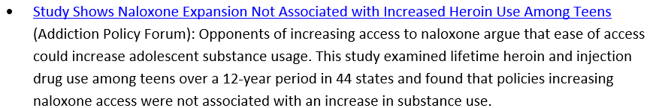
https://www.addictionpolicy.org/post/study-shows-naloxone-expansion-not-associated-with-increased-heroin-use-among-teens?mkt_tok=NzczLU1KRi0zNzkAAAGMY3xkO9L0nSA-xFlkIBGQrgcWzuuo_q7gSgwfB-fZtxFLcKKF4n_fSEq58q7PEzeRGflWBjtWszI4kWig4eIOMZX7csXoXO4t_sNRdgC7_pg

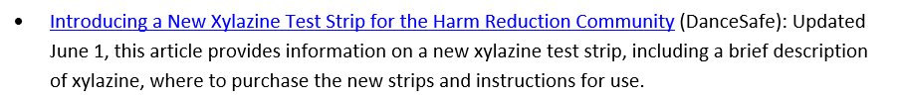
https://dancesafe.org/xylazine-test-strips/?mkt_tok=NzczLU1KRi0zNzkAAAGMY3xkPE9WxcVNKbIb-fKH_qIEnkiJBbmkgqDthd3IhaT-tSlp-wncFqOtFjupIueckc2XVbHD3ssoPRebVttAAvQDctnvtmbxhAG9WuuIQSQ
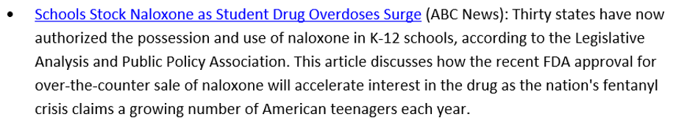
https://www.addictionpolicy.org/post/study-shows-naloxone-expansion-not-associated-with-increased-heroin-use-among-teens?mkt_tok=NzczLU1KRi0zNzkAAAGMY3xkO9L0nSA-xFlkIBGQrgcWzuuo_q7gSgwfB-fZtxFLcKKF4n_fSEq58q7PEzeRGflWBjtWszI4kWig4eIOMZX7csXoXO4t_sNRdgC7_pg

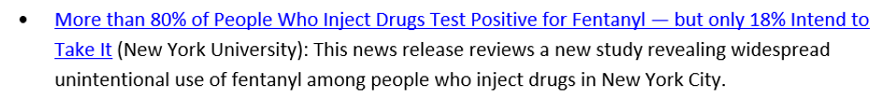
https://www.nyu.edu/about/news-publications/news/2023/may/fentanyl-new-york-city.html?mkt_tok=NzczLU1KRi0zNzkAAAGMY3xkPFqAKqGuDgxpmblO7MuTJ723HZ3gcgHJJhlUTiO6IW2xCmbAkuK0Uam6dSHhGNFDm2jn-TDukSwoj3dZ0dOsDLEtM9jsj45TODU7Hjo

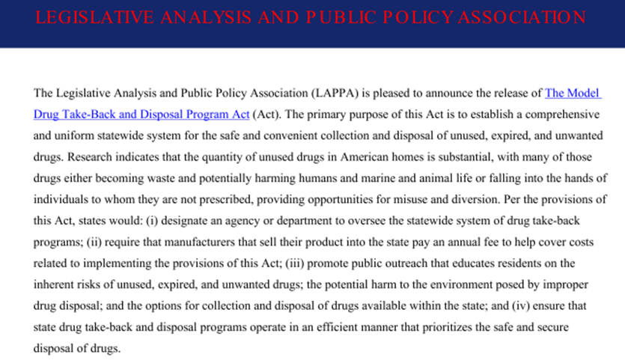
http://legislativeanalysis.org/wp-content/uploads/2023/06/Model-Drug-Take-Back-and-Disposal-Program-Act.pdf
There are three new fact sheets available on LAPPA’s website, including the fourth in a series focused on novel psychoactive substances. Isotonitazene, more commonly known as “Iso,” is a synthetic opioid for which there are currently no accepted medical uses in the United States or any other country. The substance is 500 times more potent than morphine and classified as a novel psychoactive substance since it first appeared on the illicit drug market in the U.S. in 2019. Since that time, reported seizures of Iso have increased, and like fentanyl, Iso can be mixed into other drugs to make a dealer’s product more potent and ultimately more profitable (and more deadly). Isotonitazene is classified as a Schedule I controlled substance under the federal Controlled Substances Act (CSA) and in nearly half of state CSAs. As the dangers associated with Iso grow, LAPPA will continue to monitor relevant regulatory developments.
www.legislativeanalysis.org/novel-psychoactive-substances-isotonitazene/
Ketamine is an anesthetic that has been used medically for decades in both humans and animals as a shortacting painkiller. Ketamine is classified as a dissociative anesthetic because it causes patients to feel detached from their pain and environment and because ketamine can produce such dissociative sensations, feelings of euphoria, and hallucinations, it is popular as a “club drug” among teens and young adults at dance clubs and raves. Most of the ketamine illicitly distributed in the U.S. is either diverted or stolen from legitimate sources, particularly veterinary clinics, or smuggled into the U.S. from Mexico. Illicit ketamine is found either as a clear liquid or as a white or off-white powder; liquid ketamine can be injected or mixed into drinks, while powdered ketamine can be snorted, smoked, or pressed into pills. The risk of overdose death from ketamine alone is uncommon due to the drug’s ability to cause unconsciousness with minimal impact on breathing or blood circulation. The risk of death from accidents, such as falling, drowning, or vehicular accidents, while intoxicated with ketamine, however, increases. Ketamine is often misused in combination with other substances, including alcohol, amphetamines, MDMA (commonly known as ecstasy), and cocaine, which increase the likelihood of serious complications or death. While ketamine misuse is currently rare in the U.S., reports of misuse are on the rise, and LAPPA will continue to monitor the spread of novel ketamine analogs and any new regulatory responses at the state and federal levels.
www.legislativeanalysis.org/ketamine/
Drug diversion is defined as “a criminal act or deviation that removes a prescription drug from its intended path from the manufacturer to the patient,” and while drug diversion can occur in a variety of settings and be committed by anyone, it is particularly likely to occur in healthcare settings by healthcare workers due to the ease in which they can access prescription drugs. Drug Diversion in Healthcare is a serious issue that can result in patient harm, financial loss to the healthcare entity, and civil and criminal litigation based on the perpetrator’s actions. Some researchers estimate that as many as 10 to 15 percent of all healthcare workers divert drugs at least once in their careers, with most of the medications diverted from healthcare settings being used to support the use (or misuse) of the drug by that same healthcare worker. A healthcare worker can divert drugs through several mechanisms: (i) false documentation (e.g., stating in a patient’s medical record that the worker gave the patient the drug without doing so or falsely listing a medication as wasted); (ii) scavenging wasted medication (e.g., removing residual medication from used syringes or the trash); or (iii) theft by tampering (e.g., substituting or diluting medication with a similar looking substance, such as saline). Drug diversion in healthcare settings is an issue that can harm patients, healthcare facilities and workers, and the public in a variety of ways and can only be detected when proper controls are in place.
www.legislativeanalysis.org/drug-diversion-in-health-care/

